|  |
| --- |
|  |
| Capstone Project Document |

**Vietnamese Medicinal Plants Network**

Report #6 – User Guide

|  |  |  |
| --- | --- | --- |
| **Vietnamese Medicinal Plants Network** | | |
| **Group Members** | Nguyễn Minh Tiến | SE02545 |
| Trần Bình Khánh | SE02764 |
| Nguyễn Hải Đăng | SE02992 |
| Hoàng Thị Quỳnh | SE02639 |
| **Supervisor** | Mr. Nguyễn Văn Sang | |
| **Project code** | VMN | |

**- Hanoi, 04/2016 -**

# SIGNATURE PAGE

AUTHOR: Nguyễn Hải Đăng 15/04/2016

Team member

REVIEWERS: Nguyễn Minh Tiến 16/04/2016

Project manager

APPROVAL: Nguyễn Văn Sang --/--/--16

Supervisor

Record of change

*A - Added M - Modified D – Deleted

|  |  |  |  |  |  |
| --- | --- | --- | --- | --- | --- |
| Effective Date | Changed Item | A,M,D | Change Description | Reason for Change | Rev. Number |
| 13/April/2016 | User installation | A | Add new |  | 1.0 |
| 15/April/2016 | User guide | A | Add new |  | 1.0 |
|  |  |  |  |  |  |
|  |  |  |  |  |  |
|  |  |  |  |  |  |
|  |  |  |  |  |  |
|  |  |  |  |  |  |
|  |  |  |  |  |  |
|  |  |  |  |  |  |
|  |  |  |  |  |  |
|  |  |  |  |  |  |
|  |  |  |  |  |  |
|  |  |  |  |  |  |
|  |  |  |  |  |  |
|  |  |  |  |  |  |
|  |  |  |  |  |  |
|  |  |  |  |  |  |

Table of Contents

SIGNATURE PAGE 1

1 Introduction 3

2 USER GUIDELINES 3

2.1 Register 3

2.2 Login 4

2.3 Search 5

# Introduction

This user's manual has been developed to help users better understand the requirements that may apply to use this website by providing them simple step by step tutorials. This manual is intended to help make website's functions more accessible and their associated requirements more understandable to users.

# USER GUIDELINES

## Register

To register account on website, the users do the steps below:

Step 1: Open browser and enter to the address bar: <http://vmn.vnvalley.com>. Homepage is displayed.

Step 2: Click on Đăng ký button in header. Users will go to Register page.

Step 3: Enter information and click on Đăng ký button or Đăng ký nhà thuốc link.

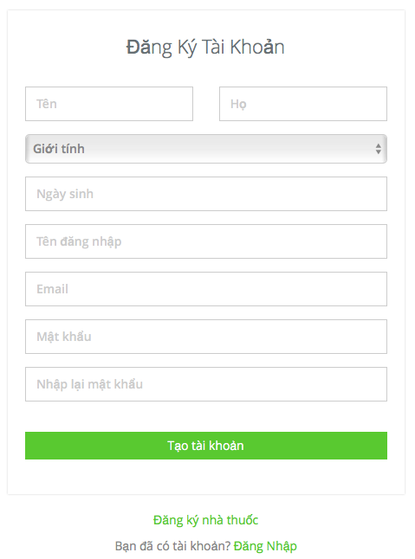

1. R**egister normal account screen**

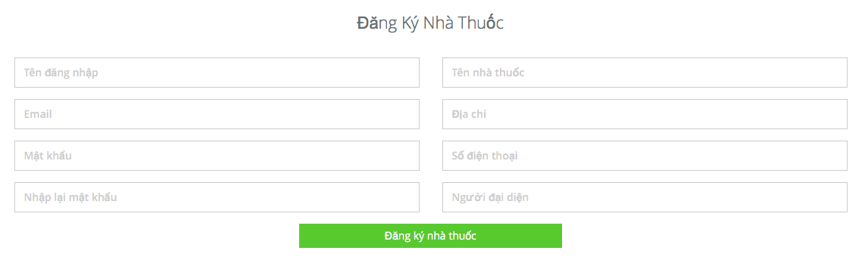

1. R**egister herbal medicine store account screen**

## Login

To login account on website, the users do the steps below:

Step 1: Open browser and enter to the address bar: <http://vmn.vnvalley.com> . Homepage is displayed.

Step 2: Click on Đăng nhập button in header. User will go to Login page.

Step 3: User login to VMN system:

Step 3.1: User enter username and password

Step 3.2: Click on Login button

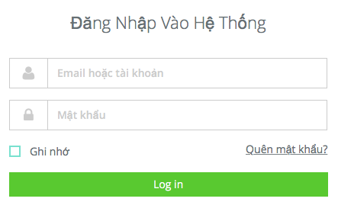

1. Login **page**

## Search

### Basic Search

To use search function on website, the users do the steps below:

Step 1: In Home page, click on medicinal plant or remedy button in header.

Step 2: Click on search icon or press enter.

Macintosh HD:Users:nguyenhaidang:Desktop:Screen Shot 2016-04-15 at 14.52.08.png

1. Basic search screen

Step3: Search result page is displayed.

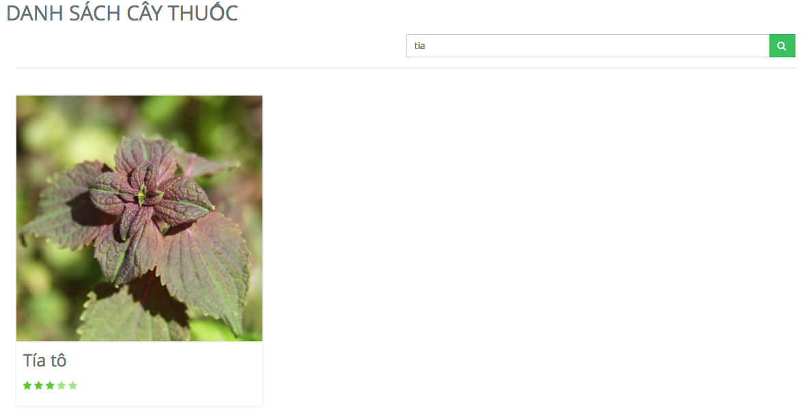

1. Search screen result

### Advance search medicinal plant

To use advance search medicinal plant function on website, the users do the steps below:

Step 1: In Home page, click on medicinal plant button in header.

Step 2: Input information and click on search icon or press enter.

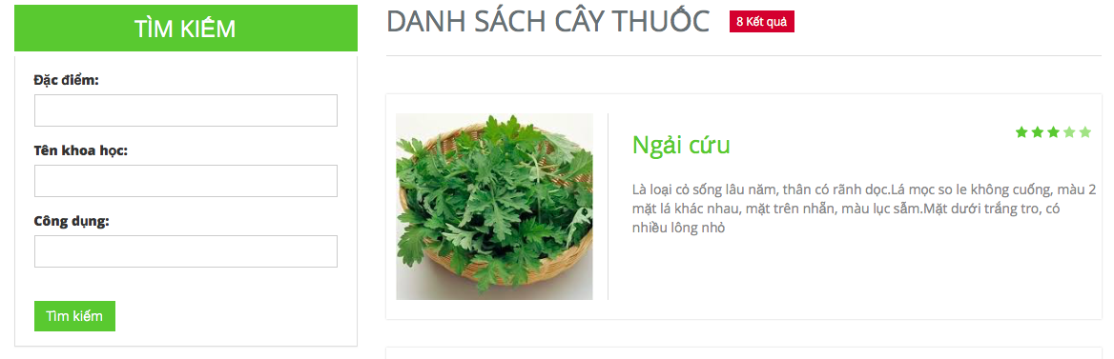

1. Advance search medicinal plant

### Advance Search remedy

To use advance search remedy function on website, the users do the steps below:

Step 1: In Home page, click on remedy button in header.

Step 2: Input information and click on search icon or press enter.

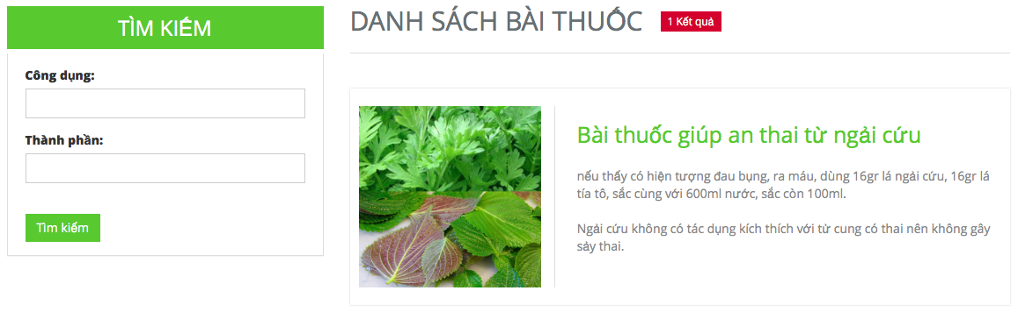

1. Advance search remedy

## Medicinal Plants

Click button Medicinal Plants in header to go to medicinal plants page

To use contribute medicinal plants article or advance search medicinal plants function on website, the users do step below:

Step 1: Click on login and sign in successful.

Step 2: In home page click on button medicinal plants in header.

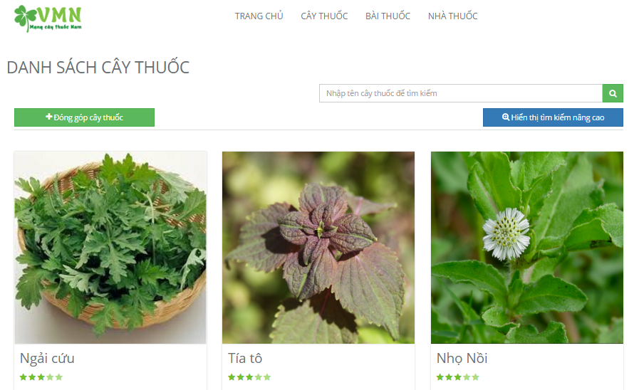

1. Medicinal plants

## Remedy

Click button Medicinal Plants in header to go to remedy page

To use contribute remedy article or advance search remedy function on website, the users do step below:

Step 1: Click on login and sign in successful.

Step 2: In home page click on button remedy in header.

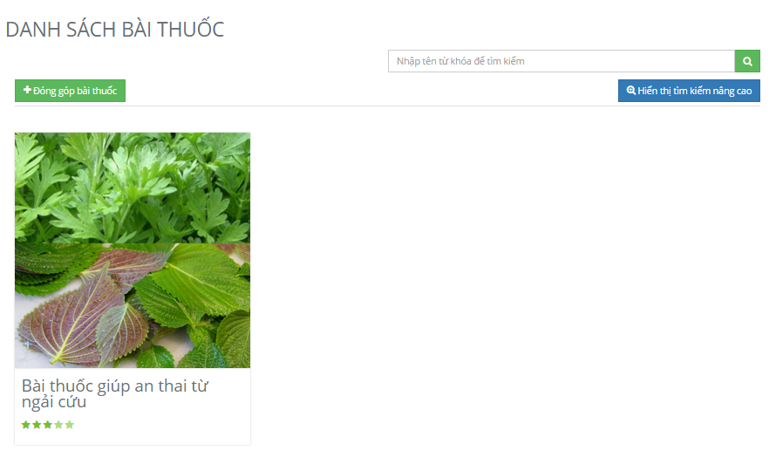

1. Remedy

## Herbal medicine store

To use herbal medicine store search function on the website, the users do the steps below:

Step 1: Click on login button in header and login vmn system successful.

Step 2: Click on herbal medicine store button in header.

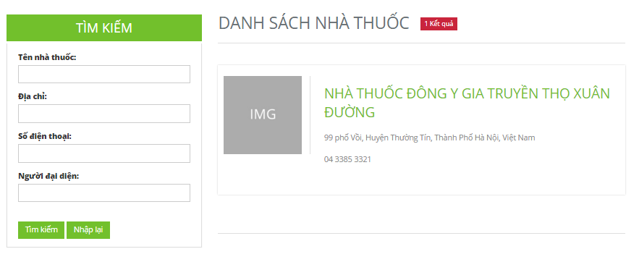

### Herbal medicine store detail

Click on a herbal medicine store in herbal medicine store page to go to herbal medicine store detail.

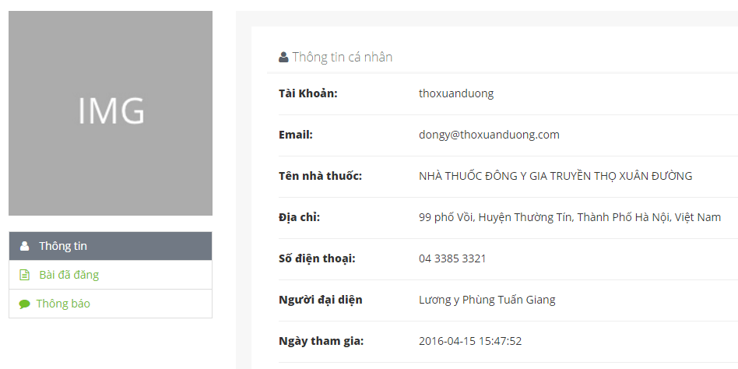

## Contribute new article

### Contribute new medicinal plant

To use contribute new medicinal plant function on the website, the users do the steps below

Step 1: Click on login button in header and login vmn system successful.

Step 2: Click on medicinal plant button in header.

Step 3: Click on Contribute new medicinal plant button.

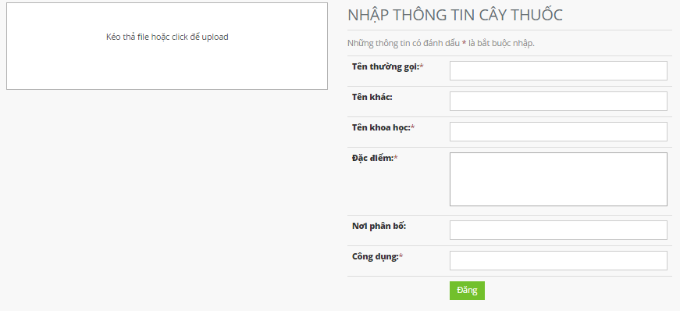

### Contribute new remedy

To use contribute new remedy function on the website, the users do the steps below:

Step 1: Click on login button in header and login vmn system successful.

Step 2: Click on remedy button in header.

Step 3: Click on Contribute new remedy button.

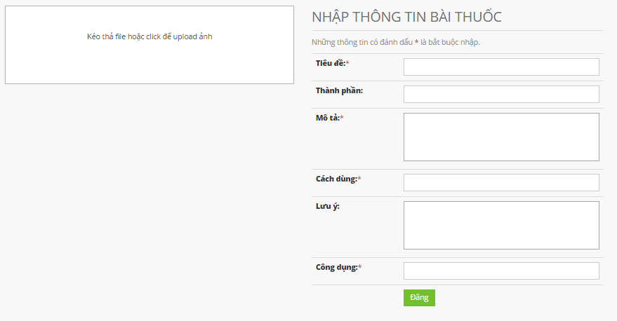

## Edit article

### Edit medicinal plants article

To use edit medicinal plants article function on the website, the users do the steps below

Step 1: Click on login button in header and login vmn system successful.

Step 2: Click on medicinal plant button in header.

Step 3: Click on a medicinal plant.

Step 4: Click on edit button. (Edit button is displayed only if the user contributed this article).

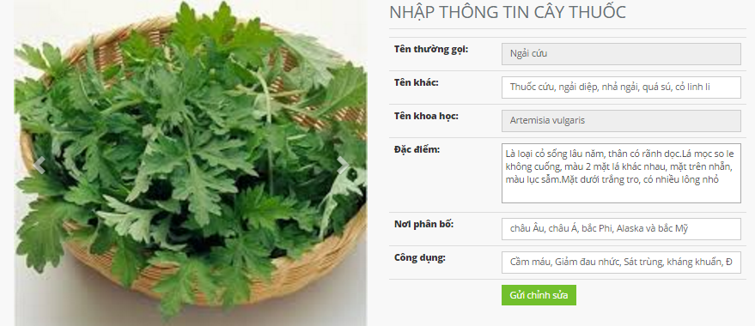

### Edit remedy article

To use edit remedy article function on the website, the users do the steps below

Step 1: Click on login button in header and login vmn system successful.

Step 2: Click on remedy button in header.

Step 3: Click on a remedy.

Step 4: Click on edit button. (Edit button is displayed only if the user contributed this article).

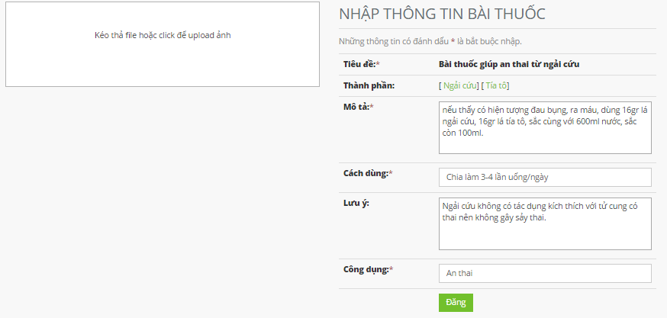

## Article detail

### Medicinal plant detail

To use medicinal plants detail function on the website, the users do the steps below

Step 1: Click on login button in header and login vmn system successful.

Step 2: Click on medicinal plant button in header.

Step 3: Click on a medicinal plant.

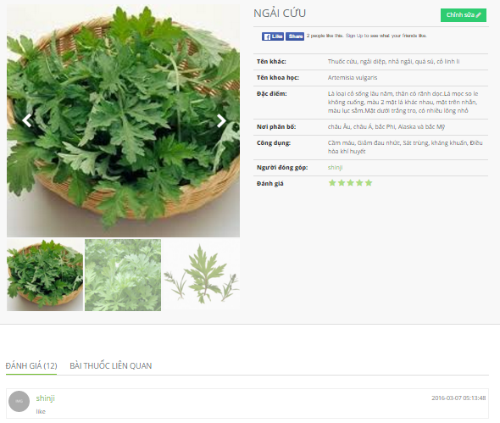

### Remedy detail

To use remedy detail function on the website, the users do the steps below

Step 1: Click on login button in header and login vmn system successful.

Step 2: Click on remedy button in header.

Step 3: Click on a remedy.

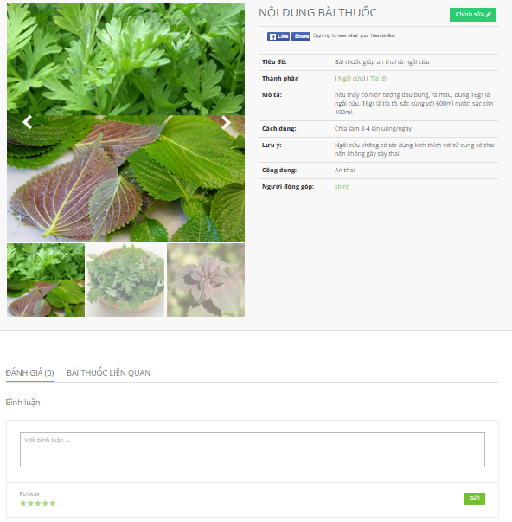

## Report